**EXPT 1: RESONANCE IN SERIES AND PARALLEL CIRCUITS**

**Circuit A:**

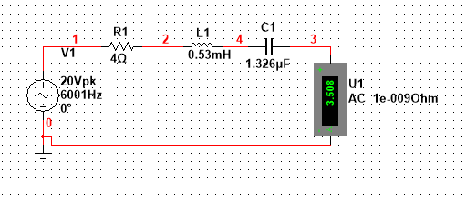

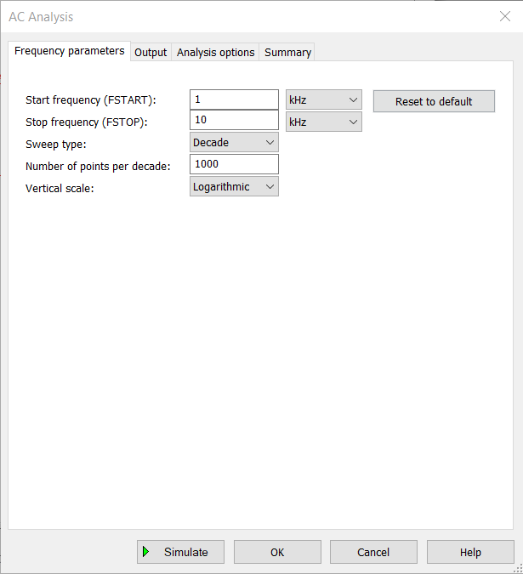 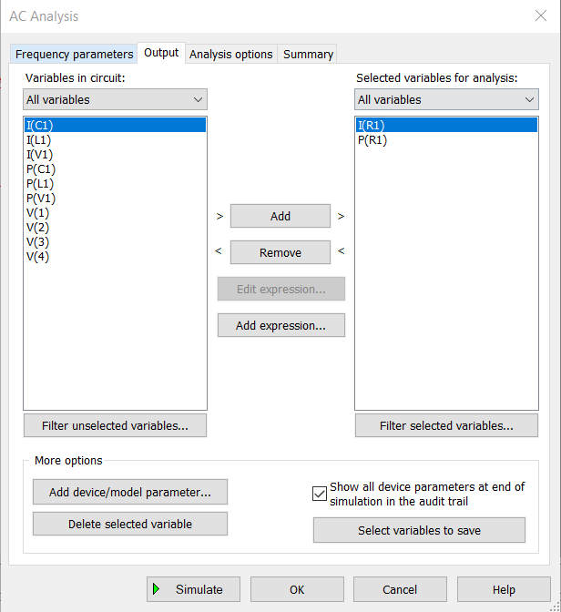

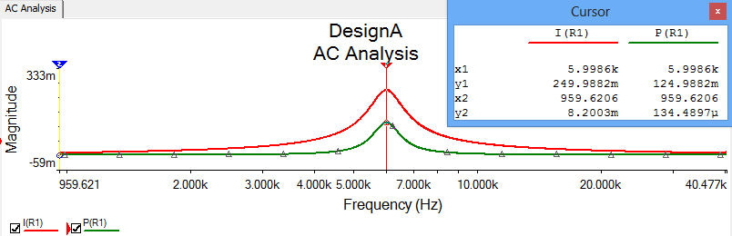

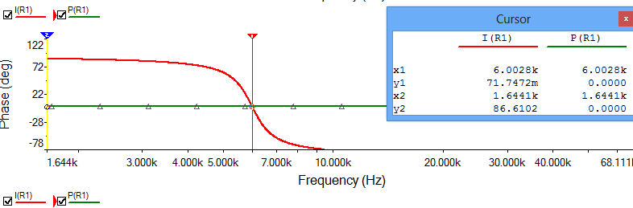

**Circuit B:**

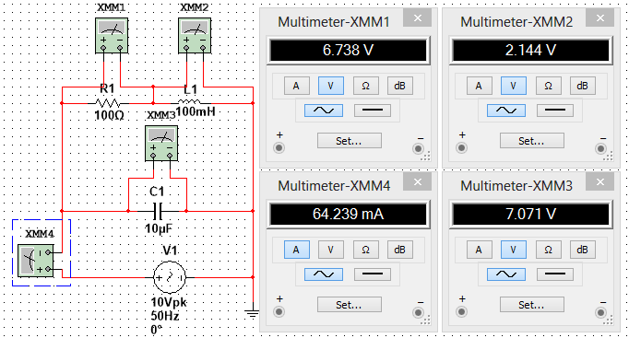

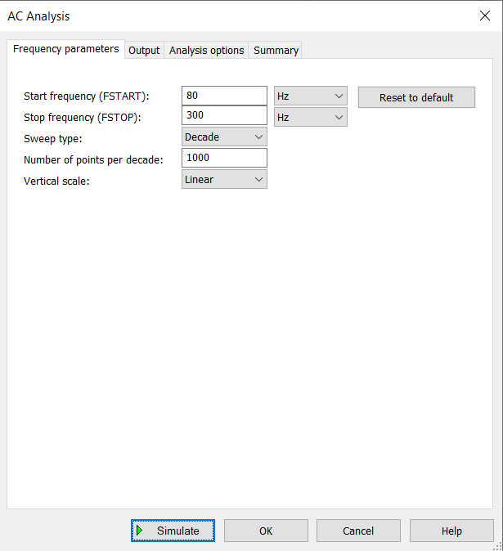 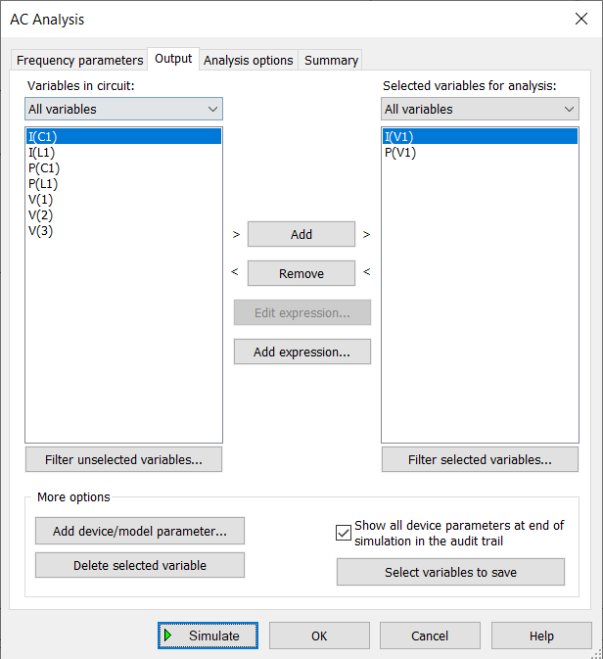

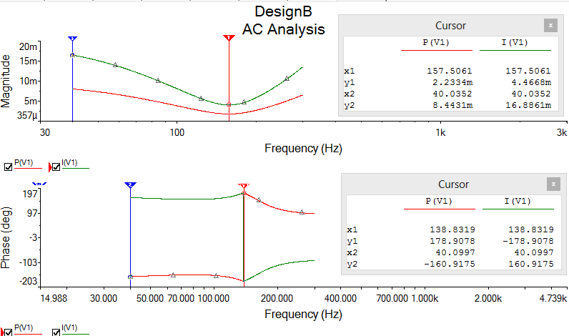



**Circuit C:**

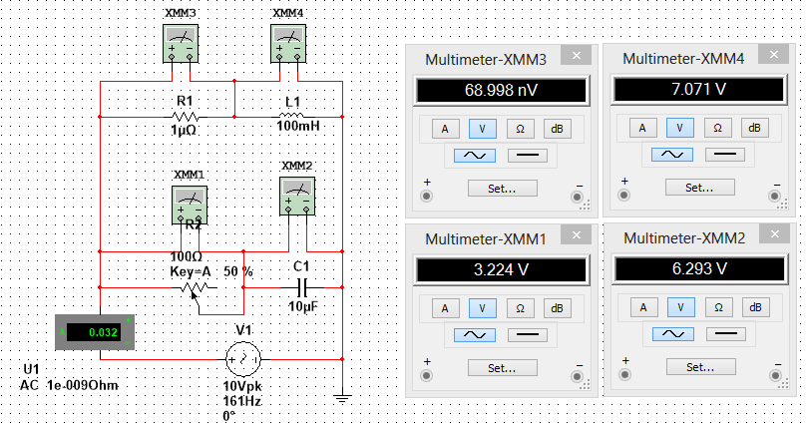

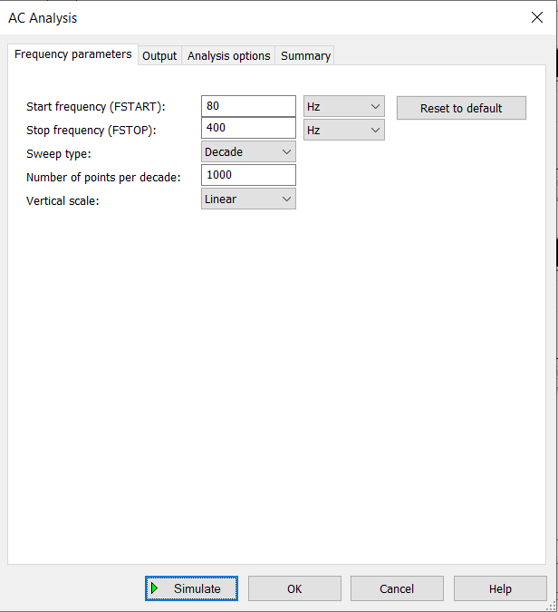 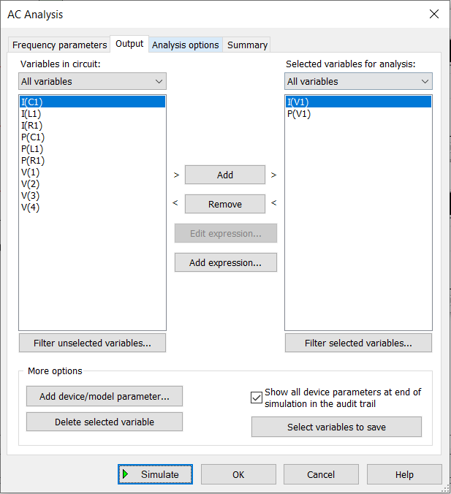

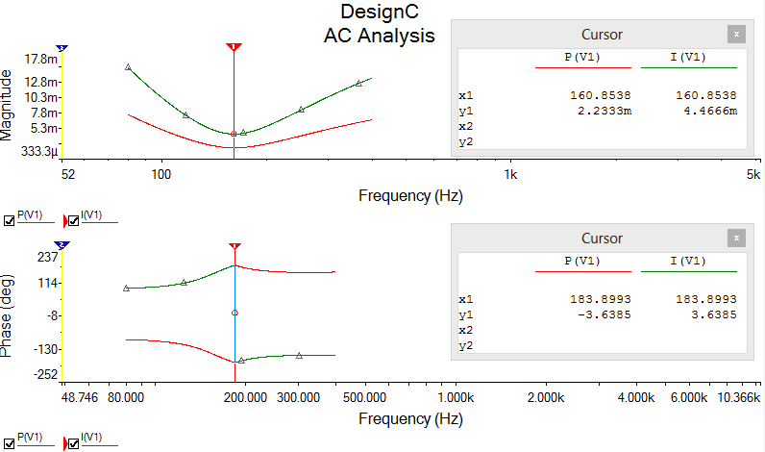

**Circuit D:**

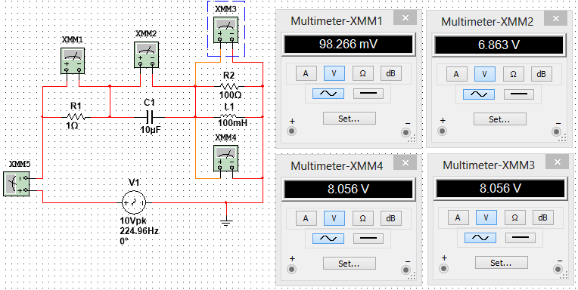

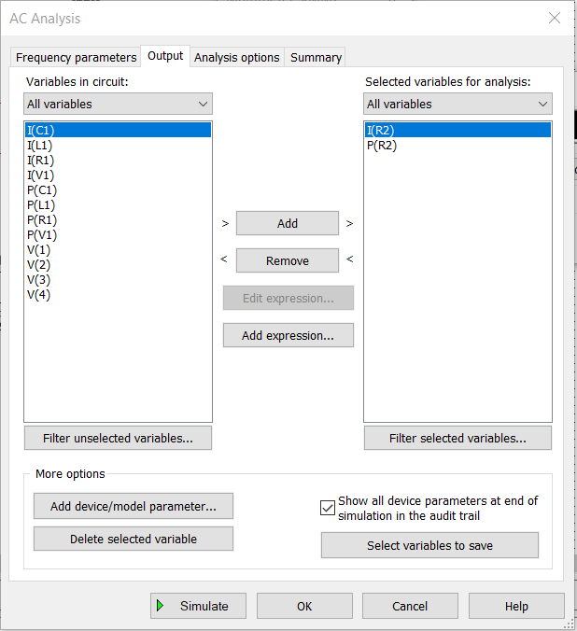 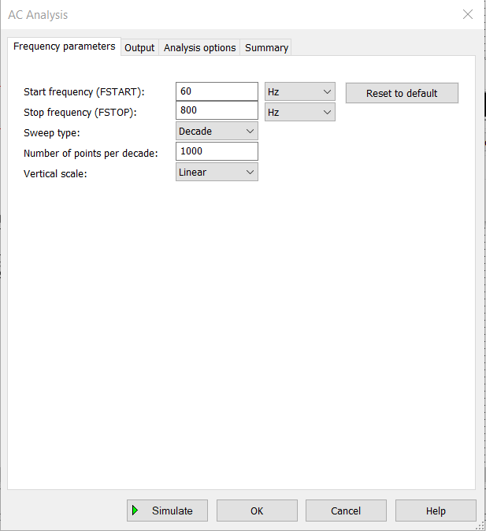

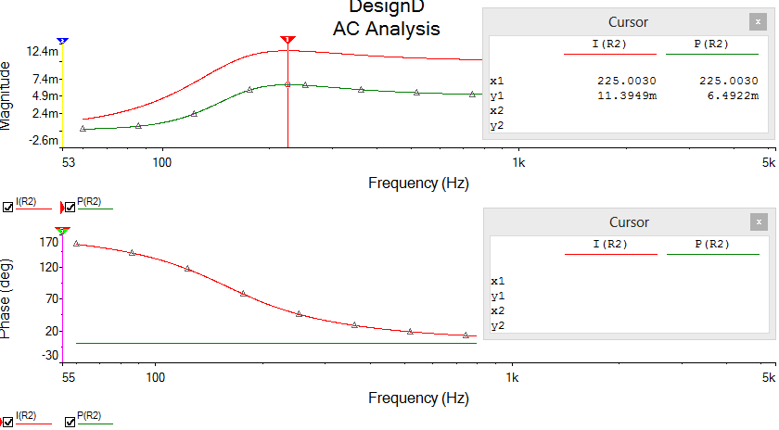

|  |  |
| --- | --- |
| Magnitude of Phase(deg) | Nature of circuit |
| >0 | Inductive |
| =0 | Resistive |
| <0 | Capacitive |

|  |  |  |  |  |  |  |  |  |  |
| --- | --- | --- | --- | --- | --- | --- | --- | --- | --- |
| Circuit | Resonating frequency | Half Power Frequency | | bandwidth | Q-Factor | Parameters at Resonance | | | |
| F1 | F2 |
| current | Vr | Vl | Vc |
| A | 6.001k | 5.4748k | 6.5834k | 6.9655k | 0.861 | 3.508 | 14.032 | 71.018 | 69.260 |
| B | 157.02 | 96.39 | 235.08 | 871.41 | 0.180 | 0.032 | 3.164 | 6.324 | 7.071 |
| C | 161.00 | 105.44 | 262.66 | 987.80 | 0.162 | 0.032 | 3.224 | 7.071 | 6.293 |
| D | 224.96 | 111.91 | 336.44 | 1410.76 | 0.159 | 0.098 | 8.056 | 8.056 | 6.863 |

2. Even after the resistor in series with L in the circuit C is removed, the circuit still shows resonance at the same frequency and same bandwidth. The circuit isn’t affected by the removal of the resistor.

3. As given in the phase diagram, the point where I(r1) and P(R1), in series LCR circuit, cross each other, that point if known as the resonant frequency of the circuit and power at that point is maximum for the circuit. Similarly, for parallel LCR circuit, we form a graph between I(V1) and P(V1) and see where both the graphs intersect in the phase diagram. It is the point where the power of the circuit is minimum and this pointy is the resonance point of the circuit.

When the current lags behind the voltage, then the circuit is an Inductive circuit. If the current leads the voltage, then the circuit is a capacitive circuit and when the voltage and current both are in phase, then the circuit is a purely resistive circuit.